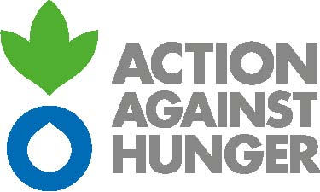

www.actionagainsthunger.org.uk
T: +44 (0)20 8293 6190
6 Mitre Passage
North Greenwich
London SE10 0ER
United Kingdom
Action Against Hunger

RUN AGAINST HUNGER
On [race date], [name of your school] will participate in the Run Against Hunger, organised by international humanitarian organisation Action Against Hunger. Every year, for over 20 years, the Run Against Hunger has helped schools around the world to raise awareness about hunger and malnutrition and to mobilise their pupils to become a part of the fight to end it by raising funds through this sponsored running event.
More than 500,000 pupils participate worldwide in the Run Against Hunger every year, raising vital funds for our life saving programmes supporting children and their families.

You can help us turn the Run Against Hunger into a great success:
- Authorise your child to participate,
- Help your child finding sponsors,
- Be a volunteer on the day of the run.

You can find the JustGiving page for sponsorship by following this link: [insert JustGiving link here]. Please share this with your child’s family and friends.

If the sponsor cannot use the schools JustGiving page. When collecting in sponsorship it is preferable that this comes in the form of a cheque made out to Action Against Hunger, to avoid too much cash being brought into school. The school will then transfer these donations to Action Against Hunger and the school will receive confirmation of their grand total from the charity.

THANK YOU IN ADVANCE FOR SUPPORTING THE RUN AGAINST HUNGER AND SUPPORTING ACTION AGAINST HUNGER’S EFFORTS TO CREATE A WORLD FREE FROM HUNGER.

LETTER OF PARENTAL AUTHORISATION
I, …………………………………………………………………………………………………………, consent to my child…………………………………… ………………………………………………………………, a student at the school………………………………………………………… ………………………………………………… participating in the Run Against Hunger organised by the international humanitarian organisation Action Against Hunger on [dd/mm/yyyy].

Date:

Signature:

In order to respect the law on the use of pictures and photographs, we also need your authorisation to film or take pictures of your child on the day of the run. Please fill in the authorisation form below and ask your child to give it to their teacher as soon as possible.

I, ……………………………………………………………………………………………………………, consent to my child……………………………… ………………………………………………………………………, a student at the school…………………………………………………………… ..…………………………………….. being photographed, filmed or interviewed on the day of the Run Against Hunger organised by the humanitarian aid organisation Action Against Hunger, and taking place on [dd/mm/yyyy].
The images or interviews will only be used for journalistic reports on the Run Against Hunger or be published within Action Against Hunger’s website, social media, printed materials and in their promotion of the campaign.

Date:

Signature:

